# Redmine - Smartsheet Integration

Goals:

* Manage timelines and project tasks for bulk operations in Smartsheet
* Connect tasks between the two systems and synchronize data between them for linked tasks
* Bulk entry of new tasks into Redmine from Smartsheet
* Not all tasks in Redmine show in Smartsheet (e.g. QA issues)
* Not all tasks in Smartsheet show in Redmine (e.g. client tasks)

The following high-level workflow is supported:

* Create new Smartsheet from template
* Enter and schedule tasks in Smartsheet, define dependencies, etc., indicating which tasks should be mirrored in Redmine
* Create new Project in Redmine (if needed)
* Enter Smartsheet ID into Redmine Project custom field on the Settings screen
* The project and Smartsheet are now connected and the PM can click the Synchronize button on the Smartsheet tab in Redmine to update both sides
  + We can look at potentially automating this but for now it will be manual
* Synchronization process:
  + Tasks in the Smartsheet that don’t exist in Redmine are created
    - ID column in Smartsheet is updated with the created ticket ID from Redmine
    - Smartsheet tasks with “-” in the ID column will not be created in Redmine
  + Redmine-managed fields for tickets that exist in both (mapped by the ID column) are updated in Smartsheet
  + Smartsheet-managed fields for tickets that exist in both (mapped by the ID column) are updated in Redmine
  + Any errors or warnings are displayed on the screen after synchronization
* Milestones in Redmine are created for tasks with “M” as the ID value and updated with “M123” where 123 is the Redmine Milestone ID after creation. Any task underneath a Milestone in Smartsheet will be added to the corresponding Milestone in Redmine, whether or not it is a direct child of the Milestone task.

Reference:

* Smartsheet API documentation: <http://smartsheet-platform.github.io/api-docs/>
* Smartsheet Ruby SDK: <https://github.com/smartsheet-platform/smartsheet-ruby-sdk>
* Test Smartsheet: <https://app.smartsheet.com/b/home?lx=5zVEWa8vykpFv8To0cSi-A>
* Test Redmine Project:

## Redmine Project to Smartsheet Connection

Projects in Redmine will store an associated Smartsheet ID in a custom field named “Smartsheet ID”. The ID of a Smartsheet can be accessed from the Properties dialog:

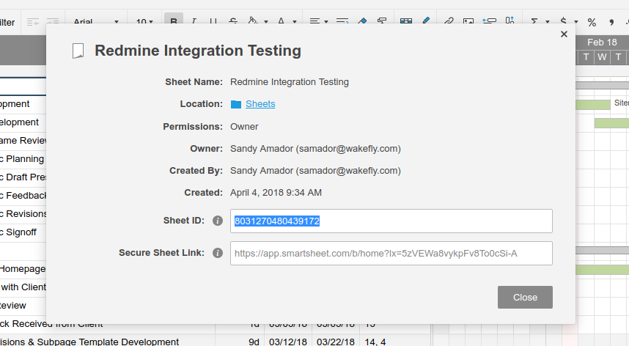

## Task Field Mapping

| **Redmine** | **Smartsheet** | **Owner** | **Notes** |
| --- | --- | --- | --- |
| ID | ID | Redmine | Value of “-” in Smartsheet indicates that the task is for the timeline only and should not be created in Redmine. Tasks with a blank ID will be created in Redmine upon synchronization, and will be updated in Smartsheet with the created task ID. |
| Subject | Task Name | Smartsheet |  |
| Milestone | <parent/ancestor task with M prefix in ID> | Smartsheet | Any task nested under a Milestone task in Smartsheet will have its Milestone set accordingly. Updated in Redmine from Smartsheet, but not the other way around. |
| Status | N/A | Redmine | Not needed in Smartsheet |
| Assignee | Assignee | Redmine | If the name in Smartsheet matches the full name of a user in Redmine, assignee will be set accordingly. Dropdown values can be populated in Smartsheet Template to make this less error-prone. Last updated record wins. See Collisions below for logic. |
| Start Date | Start | Smartsheet | One way synchronization from Smartsheet to Redmine. Field in Smartsheet is a function, so value cannot be updated from Redmine. Warning will be displayed in synchronization output if Redmine was updated more recently than Smartsheet. |
| Due Date | Finish | Smartsheet | One way synchronization from Smartsheet to Redmine. Field in Smartsheet is a function, so value cannot be updated from Redmine. Warning will be displayed in synchronization output if Redmine was updated more recently than Smartsheet. |
| Estimate | Estimate | Redmine | WARNING: This column must be kept hidden in Smartsheet, and only shown while edits are being made. Otherwise links shared with clients will expose this information. |
| Additional | Additional | Redmine | See WARNING above. |
| Description | Description | Redmine |  |

## Milestone Field Mapping

| **Redmine** | **Smartsheet** | **Owner** | **Notes** |
| --- | --- | --- | --- |
| ID | ID | Redmine | Value of “M” in Smartsheet indicates the task is a Milestone and will be created as such in Redmine. After creation, the ID value in Smartsheet will be updated to “M123” where 123 is the Redmine Milestone ID. |
| Name | Task Name | Smartsheet |  |
| Status | N/A | Redmine | Not in Smartsheet |
| Due Date | Finish |  | One way synchronization from Smartsheet to Redmine. Field in Smartsheet is a function, so value cannot be updated from Redmine. Warning will be displayed in synchronization output if Redmine was updated more recently than Smartsheet. |
| Sharing | N/A |  | Defaults to “Not Shared” for milestones created in Redmine from Smartsheet |
| Milestone Budget | Estimate | Redmine | Used as # of hours estimated for tasks, the Estimate column in Smartsheet is interpreted as a dollar amount for Milestones |

## Collisions

The following fields are available for determining which side gets overwritten in the event of a synchronization collision:

* Last Modified Date - when the row in Smartsheet or Task in Redmine was last updated
* Last Synchronized Date - stored in Redmine and updated with current date whenever synchronization completes and results in one or more changes

For fields that may be updated on both sides, the following logic determines which side gets overwritten.

* If both Redmine and Smartsheet Last Modified Dates are newer than the Last Synchronized Date (or this is the first time they are being synchronized), the side indicated as “Owner” in the field mapping table above wins (its value is copied to the other side)
* Else If Smartsheet Last Modified Date is newer than Redmine Last Modified Date, Redmine value is updated with Smartsheet value
* Else If Redmine Last Modified Date is newer than Smartsheet Last Modified Date, Smartsheet value is updated with Redmine value
* If neither Redmine nor Smartsheet dates are newer than Last Synchronized, no changes are made.

## Future Enhancements / Backlog

* Provide dropdown or search in Redmine to select from available Smartsheets